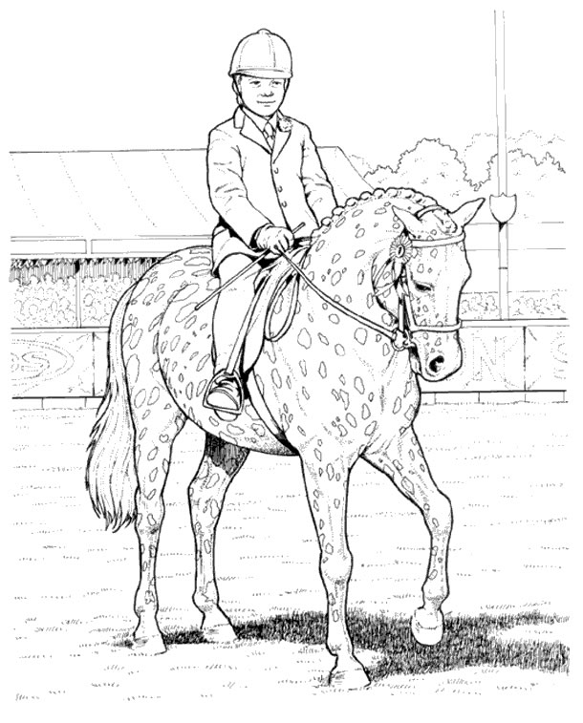
Name:
Age: Favourite Horse Discipline/Event:

