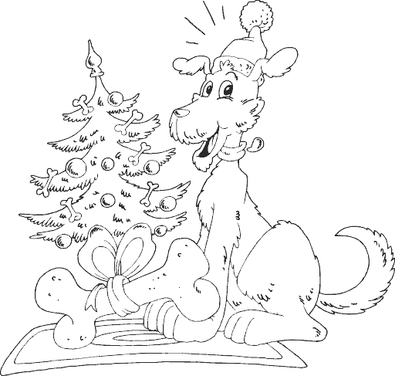


Rudolph, the red-nosed reindeer
had a very shiny nose.
And if you ever saw him,
you would even say it glows.

All of the other reindeer
used to laugh and call him names.
They never let poor Rudolph
join in any reindeer games.

Then one foggy Christmas Eve
Santa came to say:
"Rudolph with your nose so bright,
won't you guide my sleigh tonight?"

Then all the reindeer loved him
as they shouted out with glee,
Rudolph the red-nosed reindeer,
you'll go down in history!

