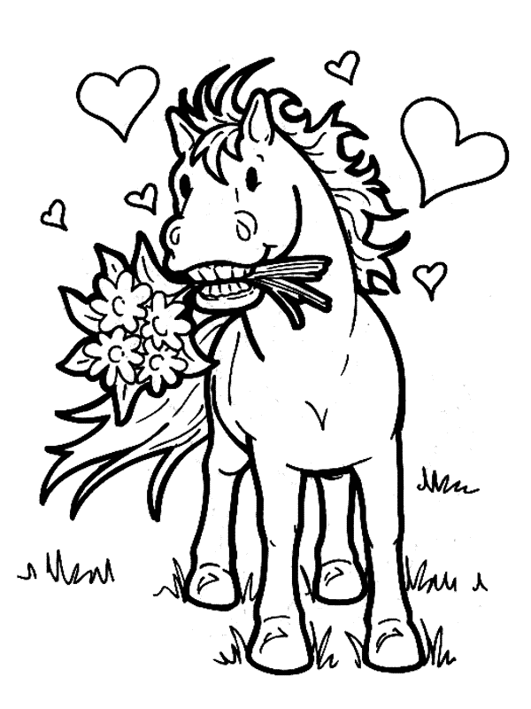
Name:
Age:
Favourite Horse Breed:

